Appendix 2

Qualitative Methodological Device

Listing of the people met during the research and some elements of presentation

Collective discussions :

The discussion group of Braine l’Alleud ( 3 sessions organised in UCP, senior association)
Id. | Gender | Age | Connections and brief elements of characterisation
R | M | 65-70 | Member of the UCP’s genealogy workshop, lives in Bl’A ‘s periferia.
J | M | 70-75 | Member of the UCP’s cyclists group, lives in Bl’A.
E | M | 70-75 | Member and neighbour of the UCP, in Bl’A. Divorced.
JM | M | 55-60 | Member of UCP’s ping pong club. Lives ine Bl’A and was recently retired.
A | F | 65-70 | Member of UCP, social affairs department Lives in Bl’A.
D | F | 60-65 | Member of UCP’s tennis club. Lives in Bl’A peripheria.
G | F | 80-85 | Member of UCP’s scrabble group, neigbour of J, widow.

The discussion group of Brasschaat (3 sessions organised in CC Brasschaat)
Id. | Gender | Age | Connections and brief elements of characterisation
R | F | 75-80 | Grand mother of one of the researcher
E | F | 90-95 | R’s neighbour
L | F | 60-65 | Acquaintance of R’s daughter
K | M | 85-90 | Neighbour of L
M | F | 65-70 | Acquaintance of R
V | F | 65-70 | Acquaintance of M
L | F | 65-70 | Acquaintance of M
I | F | 60-65 | Local network of ‘Parochieblad’
B | M | 60-65 | Local network of ‘Parochieblad’
J | F | 60-65 | Local network of ‘Parochieblad’
J | M | 60-65 | Local network of ‘Parochieblad’

The discussion group of Brussels Center (3 sessions organised in the contact center Millénaire, in Brussel’s North Railway Station area )
Id. | Gender | Age | Connections and brief elements of characterisation
T | F | 80-85 | Via local social association – neighbour and acquaintance of T, widow
T | F | 80-85 | Via local social association – neigbhbour and acquaintance of T, widow
F | F | 75-80 | Via local social association – neighbour and acquaintance of Z, arrived in Belgium during the 70’s
Z | F | 55-60 | Via local social association – neighbour and acquaintance of F, lives in Belgium since ∼1980
M | M | 75-80 | Via local social association – lives in the neighbourhood, widower

The discussion group of Leuze (3 sessions organised in the tourist information desk)
Id. | Gender | Age | Connections and brief elements of characterisation
G | M | 65-70 | Via local senior assocation, has worked on local mobility policy, lives in Leuze
C | F | 80-85 | Acquaintance of G, lives in flat service in Leuze, widow
F | F | 70-75 | Via local senior assocation, lives in a village near Leuze(Pipé)
Y | F | 65-70 | Via tourist information desk, lives in the district of Leuze, but not the center, neighbour of R & N
R | M | 65-70 | Neigbour of F, husband of N, lives in the district of Leuze, but not the center
N | F | 65-70 | Neigbour of F, wife of R, lives in the district of Leuze, but not the center

The discussion group of Sint Agatha Berchem (3 session organised in the local cultural center)
Id. | Gender | Age | Connections and brief elements of characterisation
G | F | 80-85 | Via CC De Kroon, organizes workshops on ceramics and dancing
G | F | 60-65 | Participant of senior dance group
MJ | F | 60-65 | Participant of senior dance group
D | F | 80-85 | Acquaintance of G
D | M | 80-85 | Acquaintance of G
Y | F | 70-75 | Participant senior dance group
R | F | 70-75 | Acquaintance of G

Face-to-face interviews :

 | Gender |  | Age |  | Residential localisation + connections
D | F |  | 100-105 |  | Brussels 1000 (Marolles), via local social association, lives in the same appartement since1970
L | F |  | 95-100 |  | Ellezelles, grand mother of a friend still living alone in the countryside, widow
L | F |  | 80-85 |  | Brussels 1000 (Ambiorix), via local social association, lives in the same aprtmnt since 1950, widow
A | M |  | 80-85 |  | Leuze, S’s companion, other interviewee’s father. Lives in direct peripheria of Leuze
S | F |  | 80-85 |  | Leuze, A’s companion. Lives in direct peripheria of Leuze
Y | F |  | 80-85 |  | Brussels 1000 (Marolles), via loca social association, lives in social housing, widow
G | F |  | 80-85 |  | Palncenoit, grand mother of a friend of one’s researcher
J | M |  | 65-70 |  | Leuze, Au’s husband, A’s son. Lives in the center of Leuze
Au | F |  | 60-65 |  | Leuze, J’s wife. Lives in the center
F | M |  | 70-75 |  | Braine l’Alleud, coordinator of the UCP, lives in the center of Bl’A
M | M |  | 75-80 |  | Relative of one of the researchers. Shares his life between Malaga and Antwerpen (center)
PP | M |  | 60-65 |  | Leuze - Social cab driver
R | F |  | 75-80 |  | Relative of one of the researchers, Brasschaat
Ju | M |  | 75-80 |  | Acquaintance of R, Brasschaat
The students’s corpus
Group 1 : met 10 people living in a nursing home in the center of Brussels.
Group 2 and 7 : met 10 people living in the neighbourhood of Charleroi and Tournai, country side. They mainly met people living in couples.
Group 3 : met 8 inhabitants of the area of university of Brussels (ULB).
Group 4 : met people via a local bridge association. Most of them living in Woluwé.
Group 5 : met specifically older users of the Brussels’s public transport network.
Group 6 : met older adults considered as « active » : working as volunteer in a an association, met during as senior excursion, …
Elements of presentation of the respondents of the students quoted in this report
J |  | M |  | 75-80 | District of Charleroi, lives in couple, motorised
M |  | F |  | 80-85 | Brussels, lives in a a nursing home. Is not allowed to move outdoor alone
E |  | F |  | 75-80 | Brugelette, lives in, in couple, drives by pleasure
E |  | F |  | 70-75 | near Soignies, lives in a village in couple, motorized
S |  | F |  | 85-90 | Molenbeek, lives alone
P |  | M |  | 70-75 | Woluwé, widowman
B |  | F |  | 75-80 | Brussels
VL |  | F |  | 60-65 | Brussels, divorced, has stopped to drive
M |  | M |  | 80-85 | Brussels, lives in a nursing home in the center of the city
V |  | F |  | 60-65 | Brussels, not retired

Collective Discussion : guidelines for the first session.
1. Presentation of the research team, the research projet (its context and objectives) and of the aims of the session.

MESsAGE

Comment évoluent les déplacements quotidiens au fil de la vie?

Les 3 partenaires:-VUB= enquête par questionnaires
-asbl Mobiel 21 = recherche –action
-ULB = discussion collectives et
entretiens en face-â-face

2. Kick off exercice : each participant in turn present himself / herself and explains, in a few words, his / her trip to join the session (how did you came here ?).

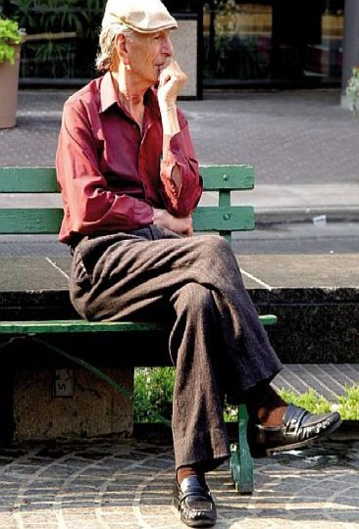
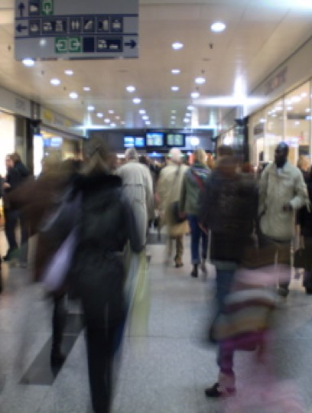
3. Photo ellicitation.
These 2 pictures evoke contrasted situations related to movements in the public space.
Collective description.
What kind of mobility situation do they evoke ?
Do you know / experience such situation ? Do you imagine yourself in such situation ? Why (not) ? What would you feel if you were there ?
<<Veillir, ça fait des trucs bizarres, tu sais.>>

(Extrait d’entretien à Plancenoit, juin 2007)

4. Commented quotation.
Has this quotation a meaning for you ?
What does it evoke ?
How do you understand it ?
If you had to precise those « weird things »,
what would they be ?

<<Les Changements? Ca se fait Petit. A la longue, tu te rends compte que tu ne fais plus les choses comme avant. >>  (Extrait d’Entretien à Brasschaat, août 2007) | 5. Commented quotation.  How do you understand this quotation ? What are those changes ? Could you name them ? Who / what do they affect ? How ? How do you react on them ? What does it change ? How do you get by ?
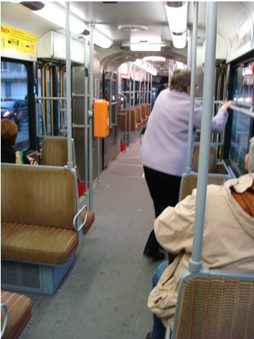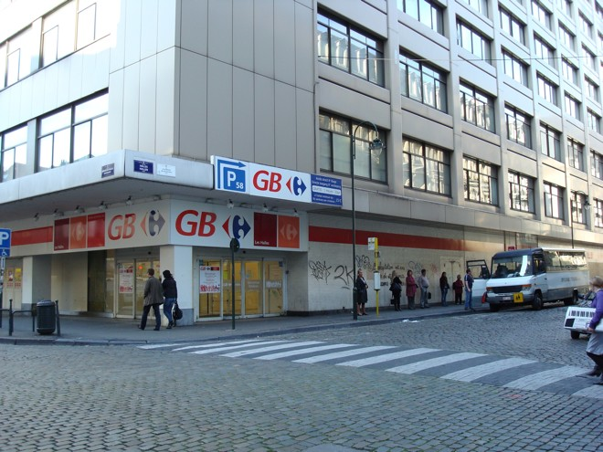

6. Comment on picture : comment local circulatory situation on the basis of picture taken during in situ observations.

Ce trajet, il me plait parce que…  Ce trajet, il me deplait parce que… | 7. Exercise : Think about one ordinary journey you like and give reasons for liking it, think about one ordinary journey you dislike and give reasons for disliking it.

<<Je ne me promène pas avec une canne, je préfère encore un parapluie. Une canne, ça fait bobonne.>>  (Une dame dans le bus à Bruxelles, août 2007) | 8. Comment on quotation :  How do you interpret this sentence ?  Do you recognize yourself in this quotation ?  Do you also use such « tricks » ? What kind of ? What are other signs of oldness ? How do you manipulate them ?  For the next session each participant bring an object, a story, a picture that allows him/her to talk about his / her former mobility practices.

Collective Discussion : guidelines for the second session.

- Pool on the basis of objectfs brought by the participants.

Each participant presents his / her object(s) and explains how it tells about a past period of his / her mobility. What is it ? How old is it ? How did you make use of it ? When ? How did it feel like ? What does it remind you? What does it represent ? Are there other participants who have used or known the same thing ? Was it better then ? When & why did you stop using it ? How has it changed now ?…

- Comment on the basis of three film sequences.
Each evokes a specific historical and geographical mobility situation: differences / changes, positive / negative aspects, sensations and feeling connected (how are those diffeneces experienced / imagined ?), generational differences (for your parents, your children, grand children ?) are developped.
  - Man with the movie camera – D. Vertov, 1929.
  - Play time – J.Tati, 1967.
  - Koyaanisqatsi – G. Reggio, 1983

- Photo ellicitation : evolution of PT devices, networks and practices
No matter if you recognize the specific places pictured, but what do those pictures evoke ?
Souvenirs …
Feelings …
Sensations …
Behaviours, habits (how were you used to do this or that ? How did it work ?)
Are there elements that surprise you ?
What are the major changes / differences you notice with situations enountered nowadays ?
Is it the sign of a major social change ? In what direction ?

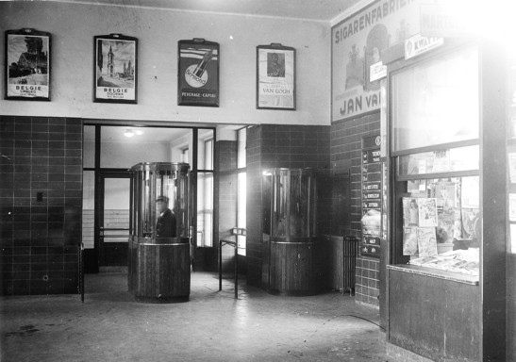
Photo SNCB Holding

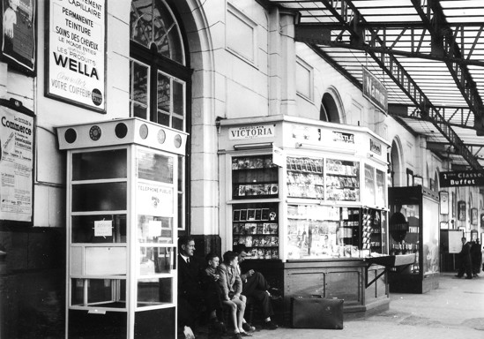
Photo SNCB Holding

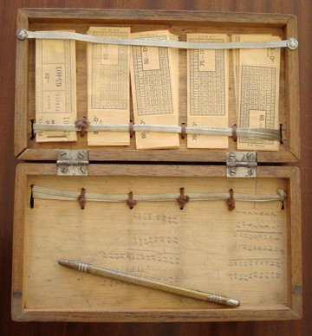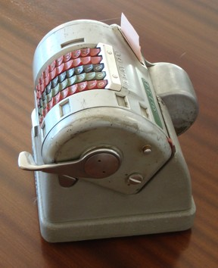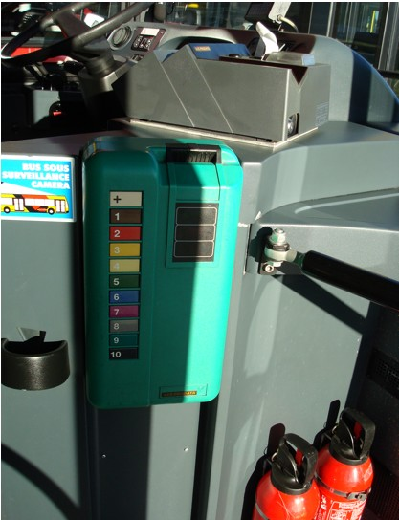

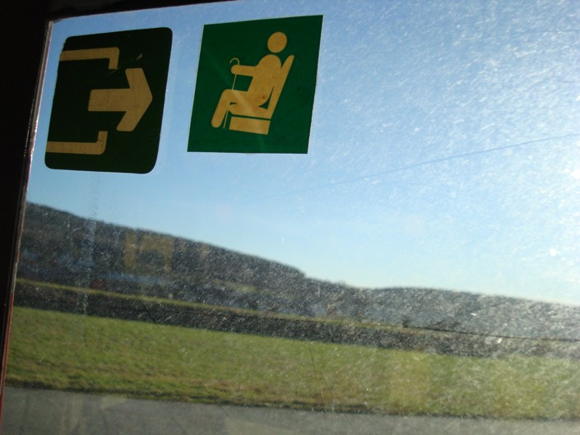
Photo ellicitation on semiotics and meanings.
Reflexion on « courtesy ».
What does it evoke ? Is it useful ? What are the differences between those two ?

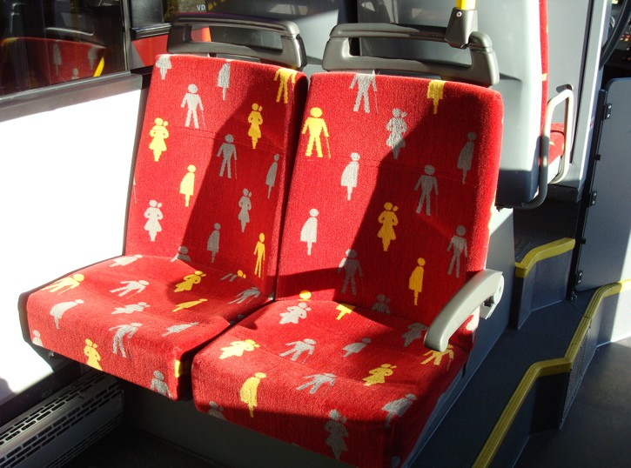
Collective Discussion : guidelines for the third session.

- Presentation of the first analysis and distribution of a working paper summarizing the preliminary results.
- Comment / debate and further fine tuning of thematics
- Concluding exercize : « Attachment board »

WHAT DO I NEED TO MOVE TODAY | WHAT DO I MISS TO MOVE BETTER

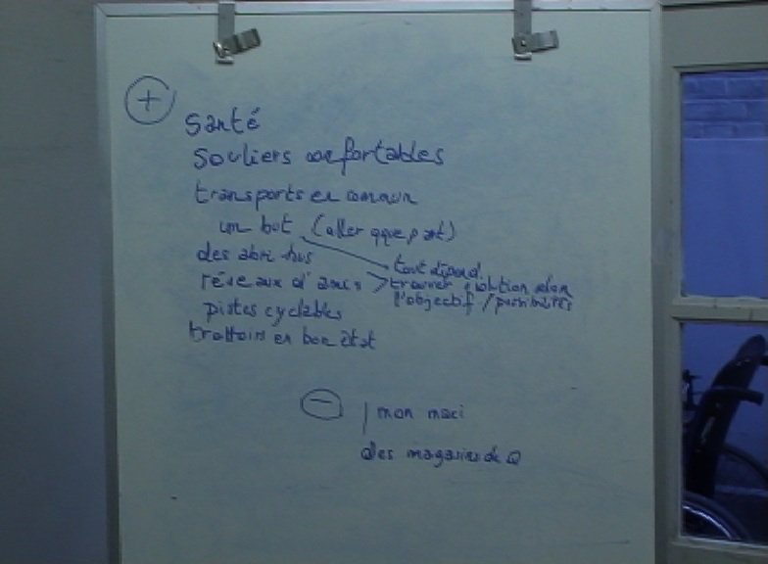 Attachment board – Braine l’Alleud

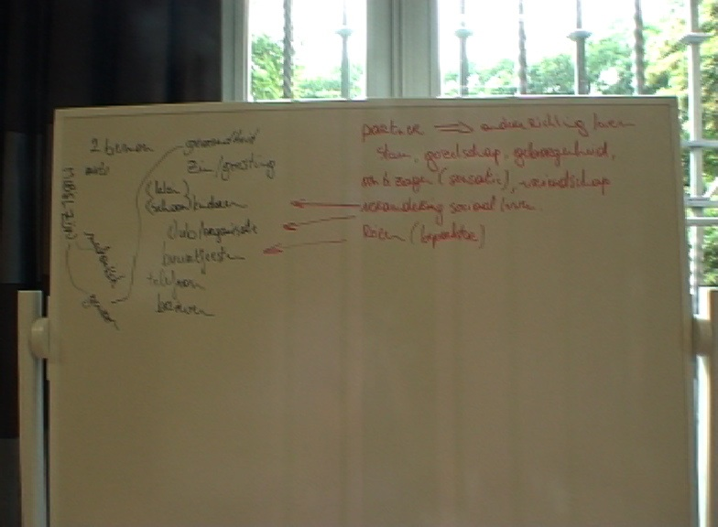 Attachment board - Brasschaat

